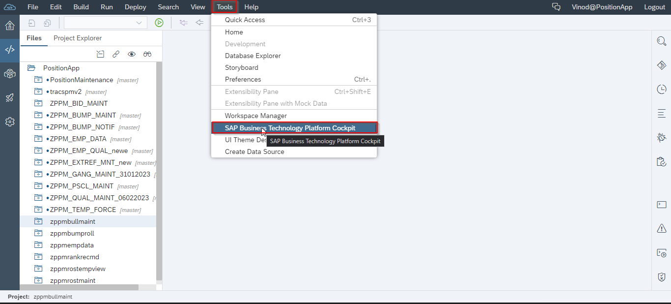

Application details from HD3 - 16

